AngularJs Blogging App

IBM PROJECT

***Submitted by***

**VINITHA.K REG NO:510420205049**

**ATCHAYA.D REG NO:510420205004**

**SHIBA BHONSLE.R REG NO:510420205040**

**BALAJI.V REG NO:510420205005**

**VIJAY.M REG NO:510420205701**

**BACHELOR OF TECHNOLOGY**

***in***

**INFORMATION TECHNOLOGY**





**ARUNAI ENGINEERING COLLEGE**

**TIRUVANNAMALAI- 606 603**

**TITLE OF CONTENT**

|  |  |
| --- | --- |
| **CHAPTER NO** | **TITLE** |
| **1** | **INTRODUCTION** |
| * 1. Overview   A brief description about your project   * 1. Purpose   The use of this project. What can be achieved using this. |
| **2** | **LITERATURE SURVEY** |
| 2.1 Existing problem  Existing approaches or method to solve this problem  2.2 Proposed solution  What is the method or solution suggested by you? |
| **3** | **THEORITICAL ANALYSIS** |
| 3.1 Block diagram  Diagrammatic overview of the project.  3.2 Software designing  Hardware and software requirements of the project |
| **4** | **EXPERIMENTAL INVESTIGATIONS** |
| Analysis or the investigation made while working on the solution. |
| **5** | **FLOWCHART** |
| Diagram showing the control flow of the solution |
| **6** | **RESULT** |
| Final findings (Output) of the project along with screenshots |
| **7** | **ADVANTAGES & DISADVANTAGES** |
| List of advantages and disadvantages of the proposed solution |
| **8** | **APPLICATIONS** |
| The areas where this solution can be applied |
| **9** | **CONCLUSION** |
| Conclusion summarizing the entire work and findings. |
| **10** | **FUTURE SCOPE** |
| Enhancements that can be made in the future. |
| **11** | **BIBILOGRAPHY** |
| References of previous works or websites visited/books referred for analysis about the project, solution previous findings etc. |
| **12** | **APPENDIX** |
| Source Code |

**1.) INTRODUCTION**

***1.1 Overview***

**User Authentication:** Secure user authentication and authorization mechanisms to ensure only authorized users can access and manage their blogs.

**Content Management:** Intuitive tools for creating, editing, and organizing blog posts, including support for rich text formatting, media embedding, and categorization.

**Interactive User Interface:** A responsive and visually appealing user interface designed to enhance user engagement and facilitate seamless navigation.

**Social Sharing:** Integration with popular social media platforms to enable users to share their blog posts and attract a wider audience.

**SEO Optimization:** Implementation of search engine optimization (SEO) best practices to improve the visibility and discoverability of blog content on search engines.

**Comments and Feedback:** Interactive features for readers to leave comments, provide feedback, and engage in discussions on blog posts.

**Analytics and Insights:** Built-in analytics tools to track key metrics such as website traffic, user engagement, and post performance, enabling users to gain valuable insights into their audience and content.

**Customization Options:** Flexible customization options for users to personalize the design, layout, and appearance of their blogs to reflect their unique style and branding.

**Community Features:** Community-building features such as user profiles, following/follower relationships, and notifications to foster connections and collaboration among users.

**Security and Privacy:** Robust security measures to protect user data, prevent unauthorized access, and ensure compliance with data privacy regulations.

***1.2 Purpose***

The main purpose of a blogging platform is to **empower individuals and organizations** to express themselves, share their ideas, connect with others, and contribute to the online conversation in a meaningful and impactful way.

**2.) LITERATURE SURVEY**

*2.1 Existing problem*

**SEO Limitations:** AngularJS applications often rely heavily on client-side rendering, which can pose challenges for search engine optimization (SEO). Ensuring proper indexing by search engines and achieving good search rankings can be more difficult compared to traditional server-side rendering.

**Performance Optimization:** AngularJS applications may experience performance issues, particularly with large amounts of dynamic content or complex user interfaces. Optimizing performance, reducing load times, and minimizing rendering bottlenecks require careful design and implementation.

**Security Concerns:** AngularJS applications are vulnerable to various security threats, such as cross-site scripting (XSS) attacks and data breaches. Proper implementation of security best practices, such as input validation, output encoding, and secure communication protocols, is essential to mitigate these risks.

**Compatibility Issues:** AngularJS may not be fully compatible with older browsers or devices, leading to inconsistent user experiences across different platforms. Ensuring cross-browser compatibility and graceful degradation for unsupported features can be challenging.

**Complex State Management:** Managing application state and data flow in AngularJS applications, especially those with complex user interactions and multiple components, can become cumbersome. Effective state management solutions, such as using services, observables, or state management libraries like NgRx, may be necessary to maintain a manageable codebase.

**Accessibility:** Ensuring accessibility for users with disabilities, such as screen readers or keyboard navigation, can be challenging in AngularJS applications. Properly implementing accessible markup, keyboard shortcuts, and ARIA attributes is crucial for inclusive user experiences.

**Maintenance and Scalability:** As AngularJS applications grow in size and complexity, maintaining and scaling the codebase becomes increasingly challenging. Adopting modular architecture, following best practices for code organization, and implementing automated testing and continuous integration can help mitigate maintenance issues and facilitate scalability.

**Learning Curve:** AngularJS has a steep learning curve, especially for developers unfamiliar with modern JavaScript frameworks or MVC (Model-View-Controller) concepts. Providing adequate training and resources for team members, as well as adopting consistent coding standards and conventions, can help address this challenge.

**Dependency Management:** Managing dependencies and keeping them up to date in AngularJS projects can be complex, especially with frequent updates and changes in the ecosystem. Using package managers like npm and version control systems like Git can help streamline dependency management and ensure consistency across the project.

***2.2 Proposed solution***

**SEO Optimization:**

Implement server-side rendering (SSR) or pre-rendering techniques to improve SEO by ensuring that search engines can crawl and index content effectively.

Use Angular Universal or similar solutions to generate static HTML snapshots of pages for search engine crawlers.

**Performance Optimization:**

Identify and address performance bottlenecks using tools like Chrome Dev Tools or Lighthouse to analyze and optimize critical rendering paths, minimize network requests, and optimize asset delivery.

Implement lazy loading for components and modules to reduce initial page load times and improve perceived performance.

Utilize Angular's built-in optimization techniques, such as Ahead-of-Time (AOT) compilation and tree shaking, to reduce bundle size and improve loading speed.

**Security Enhancement:**

Follow AngularJS security best practices, such as input validation, output encoding, and proper authentication and authorization mechanisms, to mitigate security risks.

Stay updated with security advisories and patches released by the AngularJS team and promptly apply them to your application.

**3) THEORITICAL ANALYSIS**

***3.1 Block diagram***

***3.2 Software designing***

* Program : HTML , CSS, JavaScript
* Framework : AngularJS
* Editor : Visual Studio code , Command Prompt

**4.) EXPERIMENTAL INVESTIGATIONS**

***JOURNAL SURVEY 1***

***Title:*** *Creation and Sharing of Lessons Learned by Blogging in the Context of Project-Based Learning*

***ABSTRACT:***

Over four academic years, we implemented a lessons learned management cycle in a project-based learning course, using Blogger for publishing. Analysis of 162 students and 154 lessons revealed peer-generated lessons significantly impact project outcomes, enhancing quality and reducing execution time. Students found reading and generating lessons beneficial, though the latter proved challenging yet moderately satisfying. Quality lesson creators were characterized as brilliant, valued by peers, and attentive to course activities. These findings underscore lesson generation's suitability for project-based learning, with instructor support fostering a substantial number of high-quality lessons. Overall, integrating lessons learned into educational frameworks enhances learning experiences and project outcomes, showcasing the value of collaborative knowledge sharing among students.

***JOURNAL SURVEY 2***

***Title:*** *Retention in Online Blogging: A Case Study of the Blogster Community*

***ABSTRACT:***

This paper investigates retention in the community blogging platform "Blogster," using earned points as a measure. Highly retained users tend to be central in the network, with less mutual connections among their blogger friends, and receive more views and comments on their blogs. The study also explores the homophily of retention in the social network. Through empirical observations, a classifier is developed that accurately detects top retained users with 94% accuracy. The findings contribute to the social behaviour literature of community bloggers and offer practical design insights for developers of community blogging platforms.

**5 ) FLOWCHART**

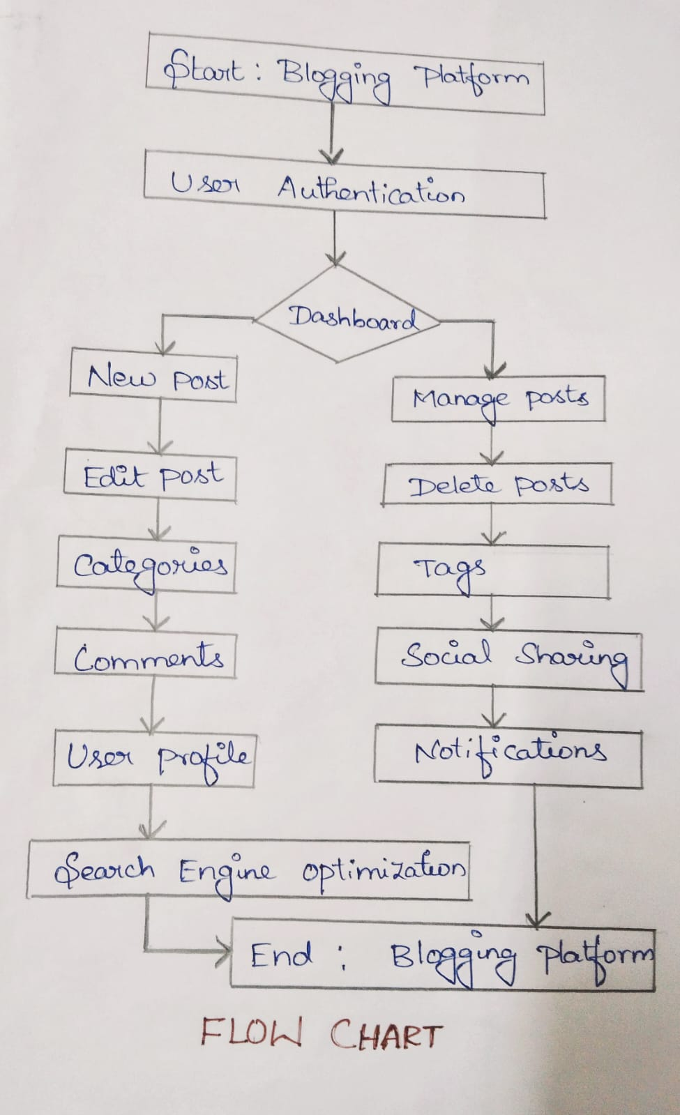

**6.) RESULT**

***6.1.***[***http://localhost:4200/***](http://localhost:4200/)

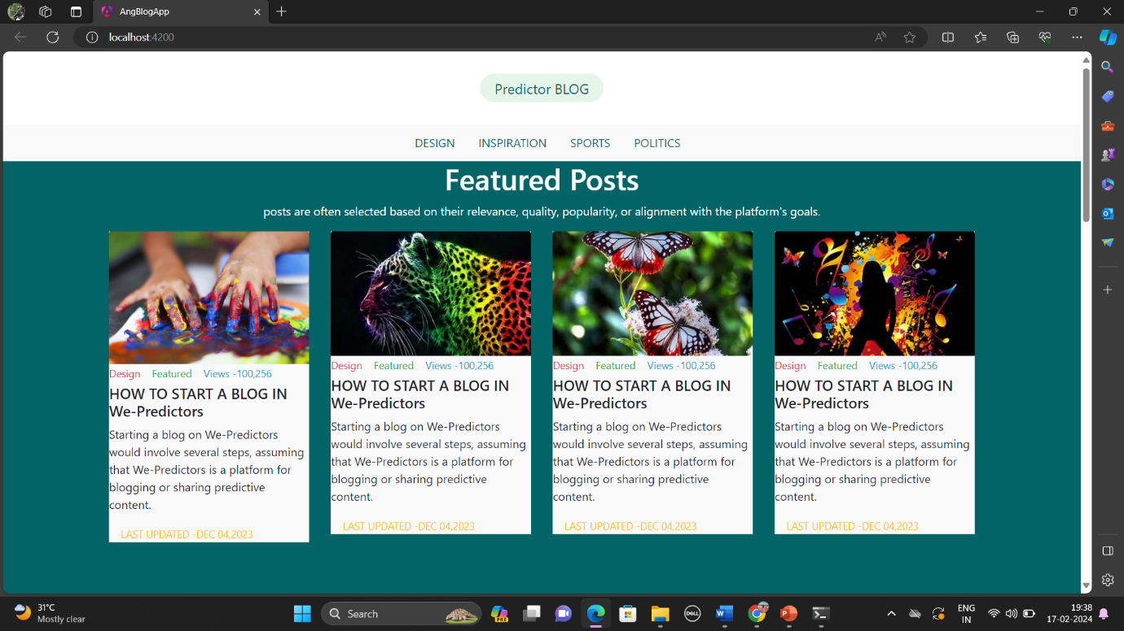

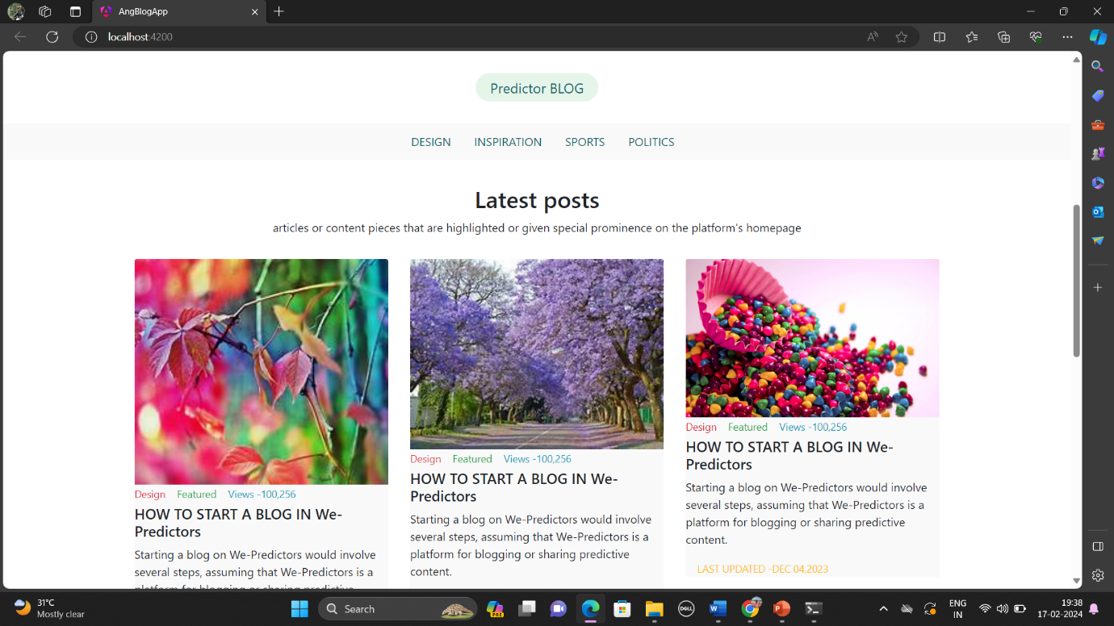

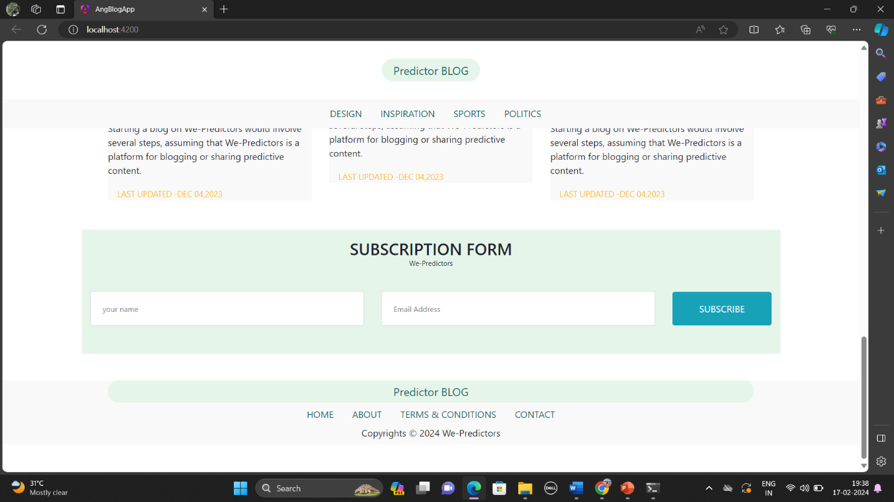

***6.2.*** [***http://localhost:4200/category***](http://localhost:4200/category)

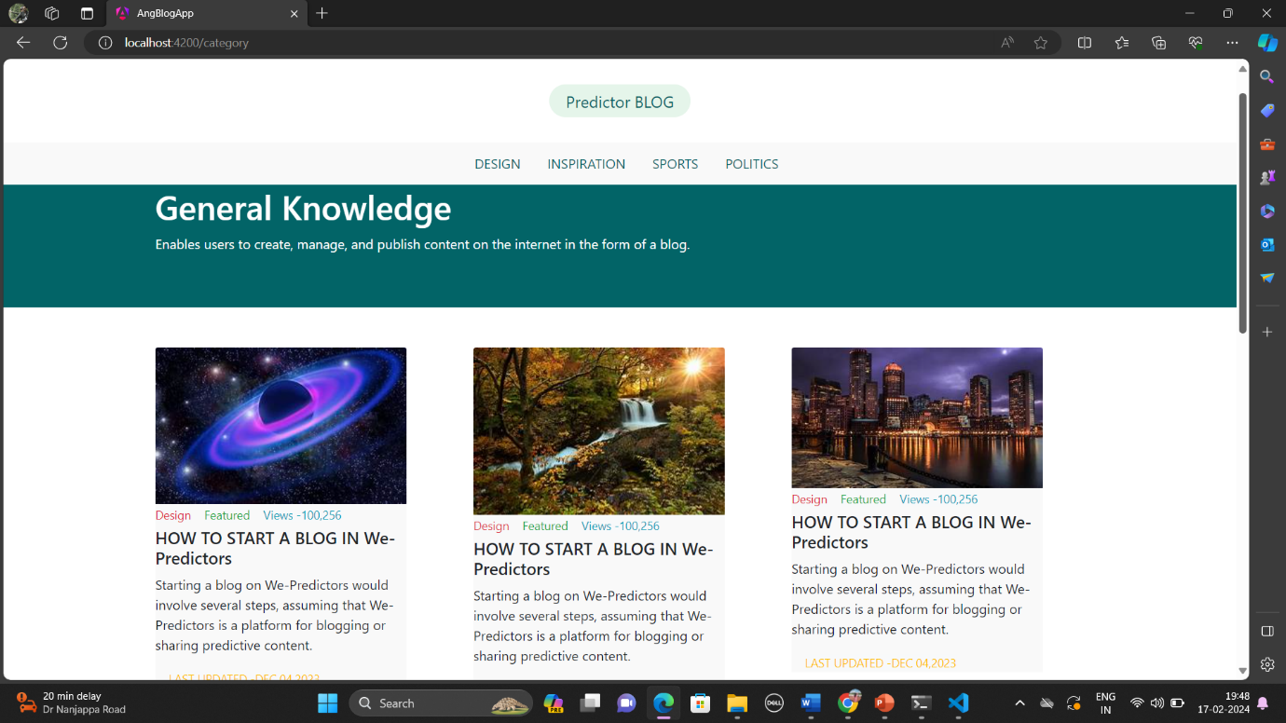

***6.3.*** [***http://localhost:4200/post***](http://localhost:4200/post)

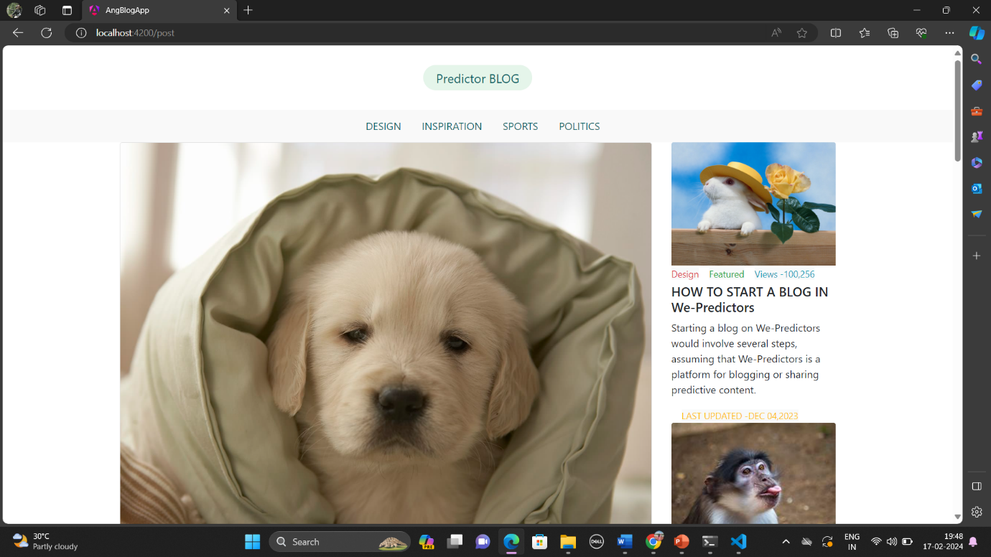

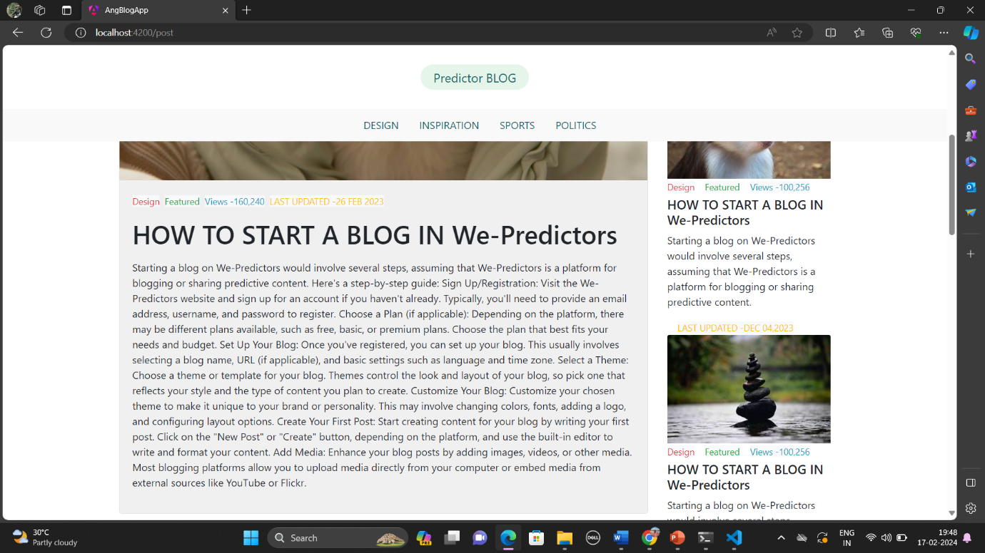

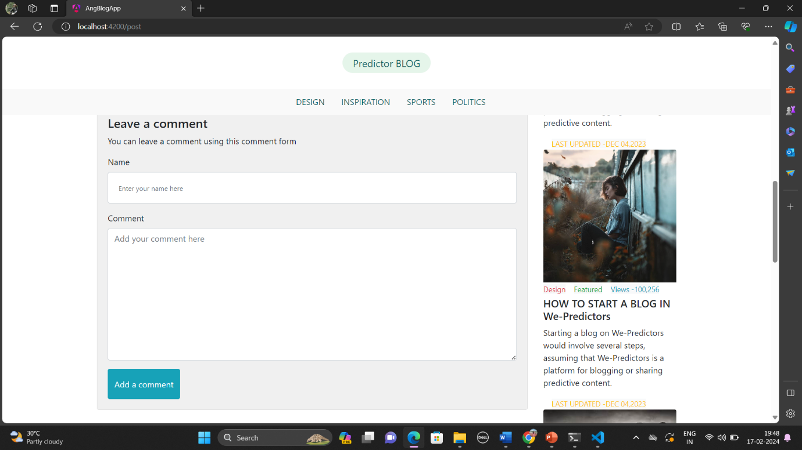

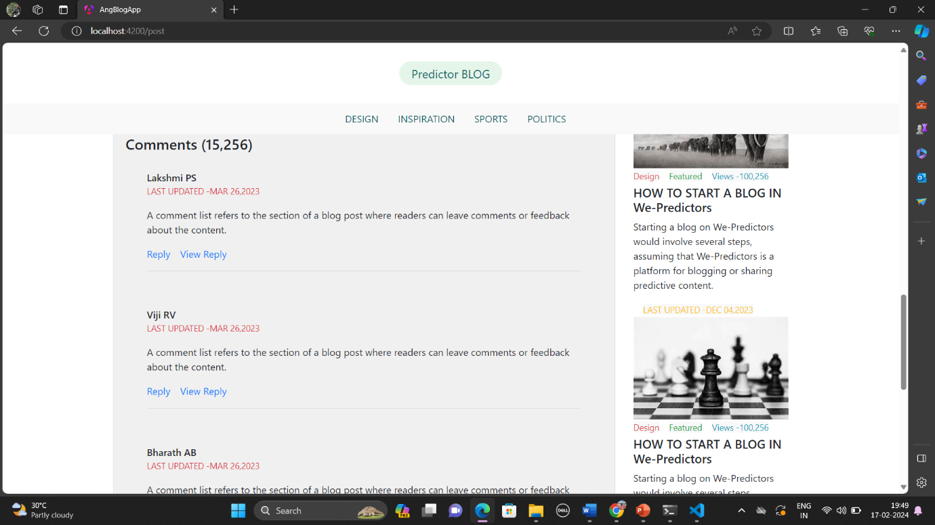

***6.4.*** [***http://localhost:4200/about-us***](http://localhost:4200/about-us)

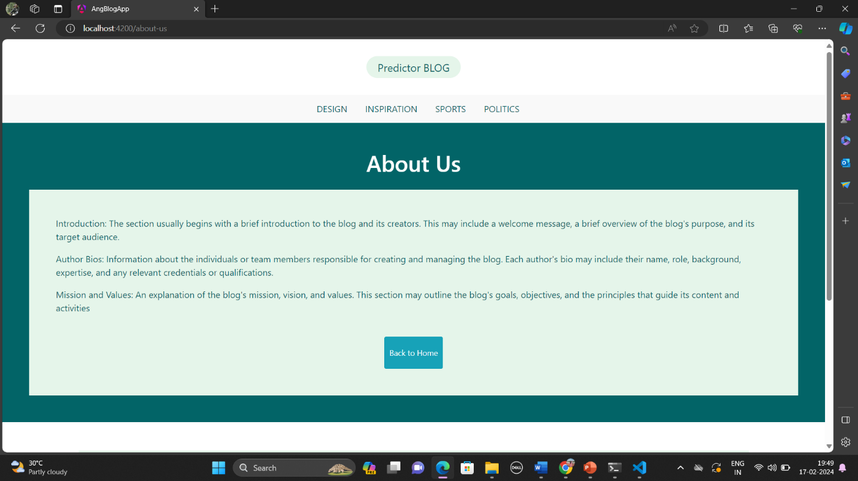

***6.5.*** [***http://localhost:4200/terms-condition***](http://localhost:4200/terms-condition)

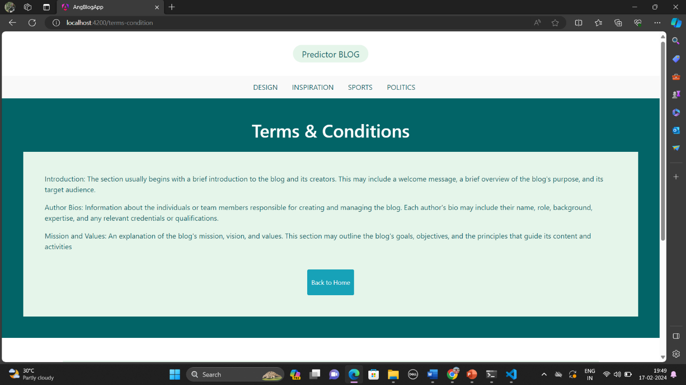

**7 .) ADVANTAGES & DISADVANTAGES**

**Advantages:**

**1.Ease of Use:**

Blogging platforms are often user-friendly with intuitive interfaces, making it easy for individuals without advanced technical skills to create and manage content.

**2.Quick Setup:**

Users can set up a blog quickly without the need for extensive coding or design skills. Many platforms offer templates that streamline the design process.

**3.Content Management:**

Blogging platforms provide tools for easy content creation, editing, and organization. Users can schedule posts, categorize content, and manage multimedia elements.

**4.Community Building**:

Many blogging platforms facilitate community engagement through features like comments, social sharing, and subscription options, fostering interaction with readers.

**5.SEO Benefits:**

Blogging platforms often include built-in SEO tools or plugins, helping users optimize their content for search engines and improve discoverability.

**6.Cost-Effective:**

Many blogging platforms offer free or affordable plans, making it accessible for individuals, small businesses, or organizations with limited budgets.

**7.Technical Maintenance:**

The platform typically handles technical aspects like hosting, security updates, and server maintenance, allowing users to focus on content creation.

**Disadvantages:**

**1.Limited Customization:**

Some blogging platforms have limitations on design and functionality customization, restricting users who desire a unique or highly tailored website.

**2.Ownership and Control:**

Users may have limited control over their content and data, as some platforms retain the right to remove or modify content according to their terms of service.

**3.Monetization Restrictions:**

Certain platforms may impose restrictions on monetization strategies, limiting the ability to generate revenue through ads, sponsorships, or other means.

**4.Dependency on Platform:**

Users are dependent on the platform's continued existence and policies. Changes or shutdowns of the platform can impact the user's blog and content.

**5.Learning Curve for Advanced Features:**

While basic features are often easy to use, mastering advanced features or customizations may require a learning curve or technical expertise.

**6.Security Concerns:**

Security vulnerabilities in the platform can pose a risk. Users need to rely on the platform's security measures or take additional steps to secure their blogs.

**7.Limited Scalability:**

As a blog grows, some platforms may become less scalable or offer fewer options for scaling up to accommodate increased traffic or additional features.

**8.) APPLICATIONS**

**Applications of AngularJS in a blogging platform:**

* Dynamic Content Rendering
* Routing
* Form Handling
* User Authentication
* Custom Directives
* Data Binding and Filtering
* SEO Optimization
* Real-time Updates
* Responsive Design
* Integration with Backend Services

By leveraging AngularJS's features and capabilities, you can create a modern and interactive blogging platform that provides a seamless user experience and meets the needs of both bloggers and readers.

**Applications of a blogging platform:**

* Personal Blogging
* Professional Blogging
* Corporate Blogging
* Educational Blogging
* Journalistic Blogging
* Niche Blogging
* Community Blogging
* Guest Blogging

Overall, blogging platforms serve as versatile tools for content creation, publishing, distribution, and engagement, catering to various purposes, audiences, and goals across personal, professional, corporate, educational, journalistic, niche, community, and guest blogging contexts.

**9) CONCLUSION**

In conclusion, an AngularJS-based blogging platform combines the power of a robust JavaScript framework with the dynamic features required for a modern blogging experience. Whether you are a content creator looking for a flexible and feature-rich platform or a developer aiming to build an interactive blogging solution, leveraging AngularJS can result in a versatile and engaging environment for both bloggers and readers.

**10) FUTURE SCOPE**

*In Blogging Platform:*

* **Advanced Content Management Features:** Integrate advanced content management features such as version control, collaborative editing, content scheduling, and content moderation to enhance the user experience for both bloggers and readers.
* **Personalization and Recommendation Systems:** Implement machine learning algorithms to provide personalized content recommendations based on user preferences, browsing history, and engagement patterns, enhancing user engagement and retention.
* **Monetization Options:** Explore various monetization options such as advertising networks, sponsored content, affiliate marketing programs, premium memberships, and subscription models to generate revenue for bloggers and the platform itself.
* **Social Networking Integration:** Enhance social networking integration by enabling users to easily share blog posts across different social media platforms, fostering community engagement and driving traffic to the platform.
* **Mobile Optimization:** Ensure seamless mobile optimization by developing responsive design layouts, native mobile apps, and progressive web applications (PWAs) to cater to the growing number of mobile users accessing content on smartphones and tablets.
* **Multimedia Integration:** Expand multimedia integration capabilities by supporting a wide range of media formats such as videos, podcasts, infographics, and interactive content to diversify content offerings and appeal to different audience preferences.
* **Localization and Internationalization:** Enable localization and internationalization features to support multiple languages, currencies, time zones, and cultural preferences, facilitating global reach and audience expansion.
* **Blockchain and Decentralization:** Explore blockchain technology and decentralization principles to enhance security, transparency, and data ownership, empowering users to have greater control over their content and interactions within the platform.
* **Voice and AI Integration:** Integrate voice recognition and artificial intelligence (AI) technologies to enable voice-activated commands, automated content creation, natural language processing (NLP), sentiment analysis, and chatbot assistance, offering innovative ways for users to interact with the platform.
* **Accessibility and Inclusivity:** Prioritize accessibility and inclusivity by adhering to web accessibility standards (e.g., WCAG) and implementing features such as screen reader compatibility, keyboard navigation, and alternative text for images to ensure that the platform is usable by individuals with disabilities.

By embracing these future-oriented strategies and continually adapting to emerging trends and user needs, a blogging platform can stay relevant and competitive in the dynamic digital landscape.

**11) BIBILOGRAPHY**

*Book Reference:*

1. **"Pro WordPress Theme Development" by Adam Onishi**

This book delves deep into WordPress theme development, which is crucial for creating a visually appealing and functional blogging platform.

1. **"WordPress All-in-One For Dummies" by Lisa Sabin-Wilson**

A comprehensive guide covering various aspects of WordPress, including setting up a blog, customizing themes, managing content, and utilizing plugins.

1. **"The Art of SEO: Mastering Search Engine Optimization" by Eric Enge, Stephan Spencer, Jessie Stricchiola, and Rand Fishkin**

Understanding SEO is essential for driving traffic to your blogging platform. This book provides a thorough overview of SEO techniques and strategies.

1. **"Content Strategy for the Web" by Kristina Halvorson and Melissa Rach**

Building a successful blogging platform requires a solid content strategy. This book offers insights into creating and managing content that engages readers and achieves business goals.

1. **"Don't Make Me Think, Revisited: A Common Sense Approach to Web Usability" by Steve Krug**

Usability is key to ensuring a positive user experience on your blogging platform. This book provides practical advice on designing intuitive and user-friendly interfaces.

**12) APPENDIX**

***Sample Source code:***

***12.1.App***

i) app.component.html

ii)app.component.css

iii)app.routes.ts

***12.2.Home***

i) home.component.html

ii)home.component.css

***12.3.Category***

i) category.component.html

ii) category.component.css

***12.4.Post***

i) post.component.html

ii) post.component.css

***12.5.Terms-condition***

i)Terms-condition.component.html

ii) Terms-condition.component.css

***12.6.About-us***

i) about-us.component.html

ii) about-us.component.css